**MayArt Group (Wue Yue, 五月畫會)**

The May (*Wu Yue*) art group, also referred to in English as the Fifth Moon art group, was formed in May 1957 by a group of painters who were graduates from the art department at the National Taiwan Normal University. Its core members included Liu Kuo-sung (Liu Guosong, 劉國松), Chuang Tse (Zhuang Zhi, 莊喆), Feng Chung-jui (Feng Zhongrui, 馮 鍾 睿), Kuo Tung-jung (Guo Dongrong, 郭東榮), Li Fang-chih (Li Fangzhi, 李芳枝), Kuo Yu-lun (Guo Yulun, 郭豫倫), Chen Jing-rong (陳景容), and Ku Fu-Sheng (Gu Fusheng, 顧福生), and they were subsequently joined by other artists including Chen Ting-shi (陳庭詩) and Han Hsiang-ning (Han Xiangning, 韓湘寧). These artists aspired to re-interpret and revitalise traditional Chinese painting using modern Western techniques and images. Their first exhibition was in 1957, after which time they regularly held exhibitions, usually in the month of May, (after which the group derives its name) until 1972 when they presented their last exhibition.

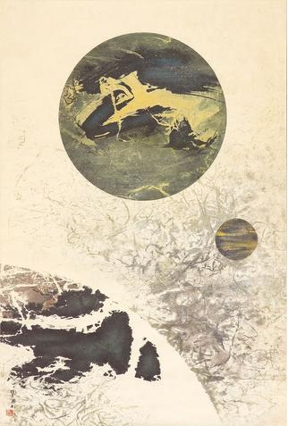

Liu Kuo-sung, *Which is Earth?*, 1969, ink and colour on paper, 115.5x77cm, private collection.

The May art group is often associated with the Eastern (*Dong Fang* or *Ton Fan*) art group. They were established within six months of each other, and in both groups the artists were predominantly painters who embraced modernism in art, and were influenced by Western abstraction. Members in the May art group, however, were more academically-oriented, with only the top-ranking graduates from the National Taiwan Normal University accepted into the group. Liao Chi-chun (Liao Jichun, 廖繼春), who was an art professor at the National Taiwan Normal University, mentored several of the artists in the May art group. While Liao embraced abstraction, he emphasised to his students the importance of technique and objective observation. His approach to teaching was more arguably more conservative compared to Li Chung-sheng’s (Li Zhongsheng, 李仲生) who mentored artists in the Eastern art group.

As a sign of the official support this group garnered, in 1962 their works were presented at the National Museum of History in an exhibition of modern art that travelled to the United States. Several members of this group went overseas and many forged successful artistic careers, especially Liu Kuo-sung (Liu Guosong, 劉國松) who is regarded today as a pioneer in the development of modern Chinese ink painting in Taiwan.

Sophie McIntyre

**References and Further Reading**

***The Experimental Sixties: Avant-Garde Art in Taiwan*, (2003), Taipei: Taipei Fine Arts Museum.**

***From the Ground Up: Artists Associations in 1950s Taiwan*, (2003), Taipei: Taipei Fine Arts Museum.**

Lu, Ching-fu (呂清夫), (1993), ‘Modernism’s Experimental Period’, in *Taiwan Art 1945-1993*, David Toman (transl.), Taipei: Taipei Fine Arts Museum, 51-61.

_________, (1991). 五月與東方：中國美術現代化運動在戰後台灣之發展 1945-1970 (*The Fifth Moon Group and the Eastern Art Group: The Development of Chinese Art Modernisation Movement in Postwar Taiwan 1945-1970*), Taipei: Tungta Publishing, (in Chinese).

*Liu, Guosong - A Universe of His Own,* (2004), Hong Kong: Hong Kong Museum of Art.